Aortic Dissection

Risk Factors
HYPERTENSION (70-90% cases)
Marfans
Ehlers-Danlos
Congenital coarctation/aortic stenosis/bicuspid aortic valve
Cocaine use
Pregnancy
Giant cell arteritis

13 January 2008
12:01
Commonest aortic emergency 3x more common than AAA rupture

History:
Pain
  - 90% worst ever pain
  - 85% abrupt onset
  - Tearing pain described 51%
  - Sharp in 64%
  - Maximal at onset
Risk Factors
Effect of side branches
- Coma/Stroke(20% present)
- Limb paraplegia
Syncope 10%

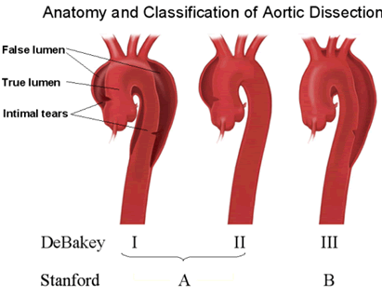

Examination
No diagnostic features
Blood Pressure maybe increased
>20 mmHg difference between arms significant
Unequal pulses seen <40%
Aortic valve incompetance 32% murmur
Horner's syndrome
Signs tamponade
Signs branch occlusion CVA/paraplegia

Investiagtions:
Need diagnostic if suspected Normal CXR unable Rule out
TOE/spiral CT Ix of choice in ED
MRI has role
CXR multitude signs 12% normal
CXR signs
  - Widened mediatinum >8mm at carina
  - Calcium sign >5mm between intimal calcium and shadow outer wall
  - NG/trachea deviated to right
  - Distortion Left main bronchus
  - Double density aorta
  - Pleural effusion (left)
  - Blurred aortic knob
ECG may show LVH only 0.9-2.4% have ECG changes of AMI 10-40% some ischaemic features
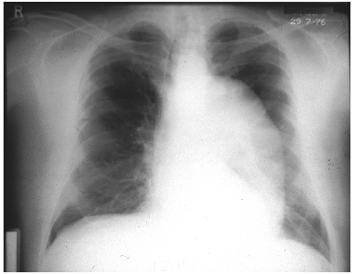

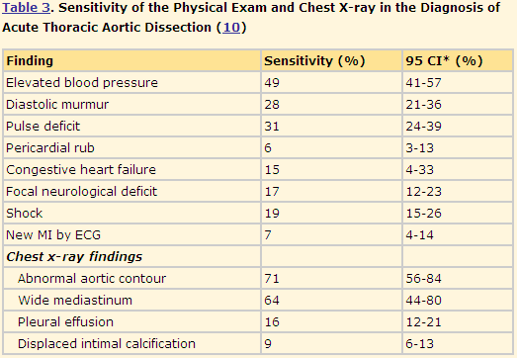
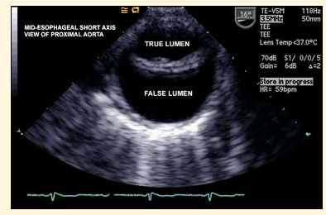
TOE

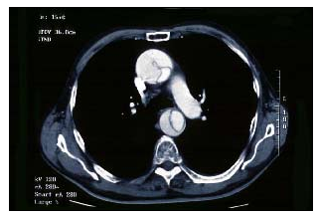

Intimal Flap ascending and descending aorta
Treatment
Reduce afterload and force of ventricualtr contraction aim
B Blockers treatment of choice
Aim HR 60-80 SBP 100-120
Sodium nitropusside alternative
Also GTN but may get reflex tachy so give B blocker as well
Analgesia
Iv access arterial line
Surgery Type A
Medical Type B surgery if leaking/failure medical therapy
One year survival 50-70% Type A
70% type B

